Network Segmentation & Containment
  - ISEC3078 – Lab 5
  - Callahan O’Quinn

Verify a flat network

Ping from Windows VM to Ubuntu VM
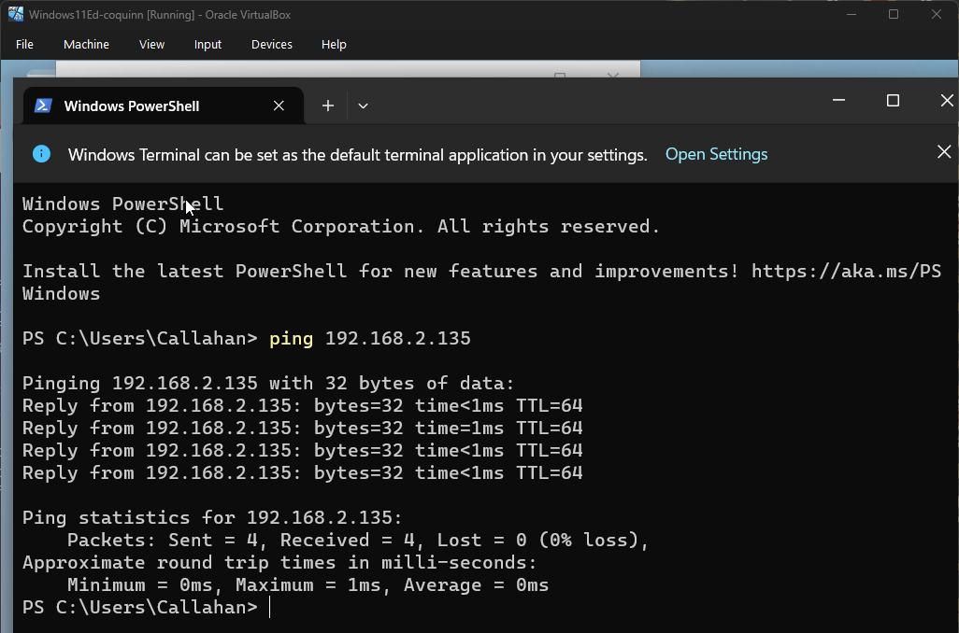

Ping from Ubuntu VM to Windows VM
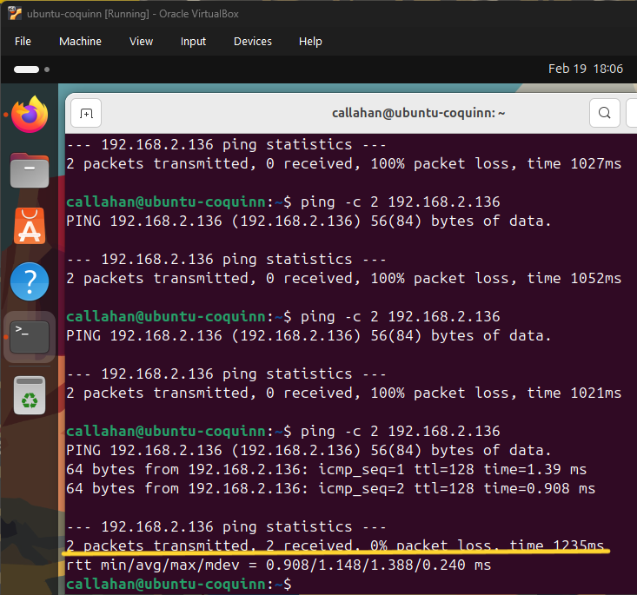

Questions
- Why is this considered a flat network?
  - It is a flat network because there is no segmentation between devices, meaning that communication does not need to be routed before reaching its destination.
- What risks does this create during an attack?
  - It is easy for attackers to move laterally through a flat network, because it has less boundaries between devices. Ransomware for example can easily hop to other devices on a flat network.

Simulate a firewall between Network Segments

Enable the firewall
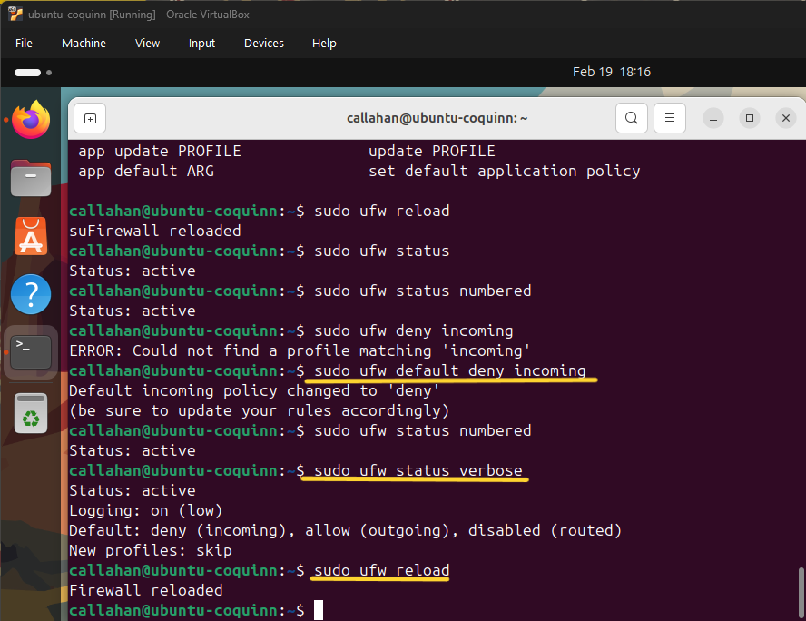

Set default firewall rules
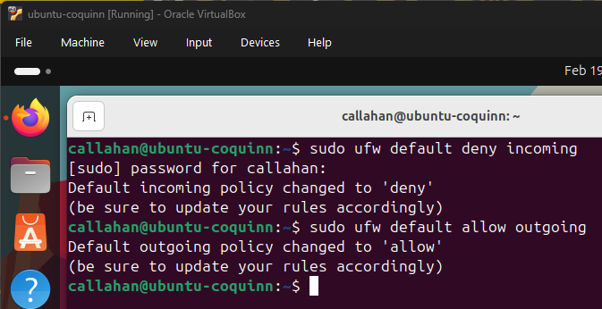

Testing connectivity
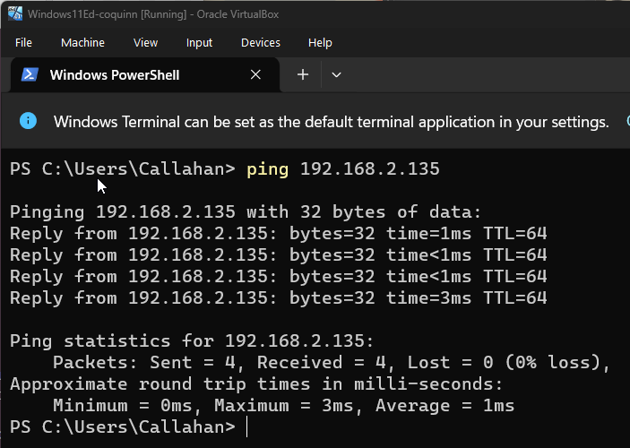

Questions
- What changes after enabling the firewall?
  - In my case, the messages still went through. I checked the rules and it said all incoming traffic should be blocked. So I’m not sure if it was because the IP of the sender was on the same segment, or if something did not work properly.
- How does this simulate placing a firewall between network segments?
  - Segmenting a network can be done in many ways, including using a firewall. Essentially you block certain traffic/ports/IPs etc. from external segments to ensure if one segment is breached, it cannot easily spread to the next.

Allow Limited Access Between Segments

Allow SSH Access
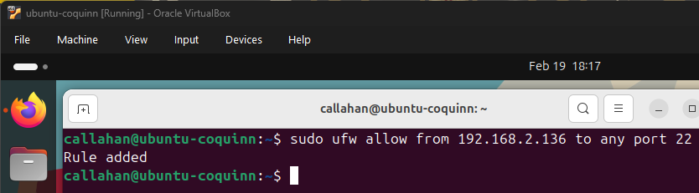

Pinging from the windows vm to the ubuntu vm
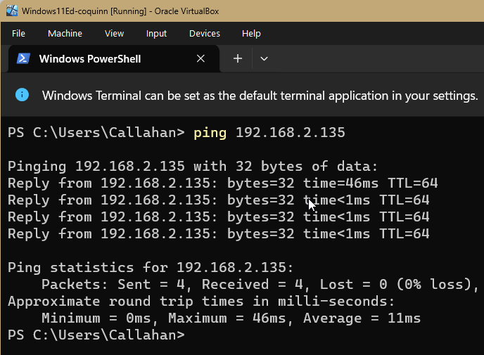

Connecting to the ubuntu vm from the windows vm with SSH
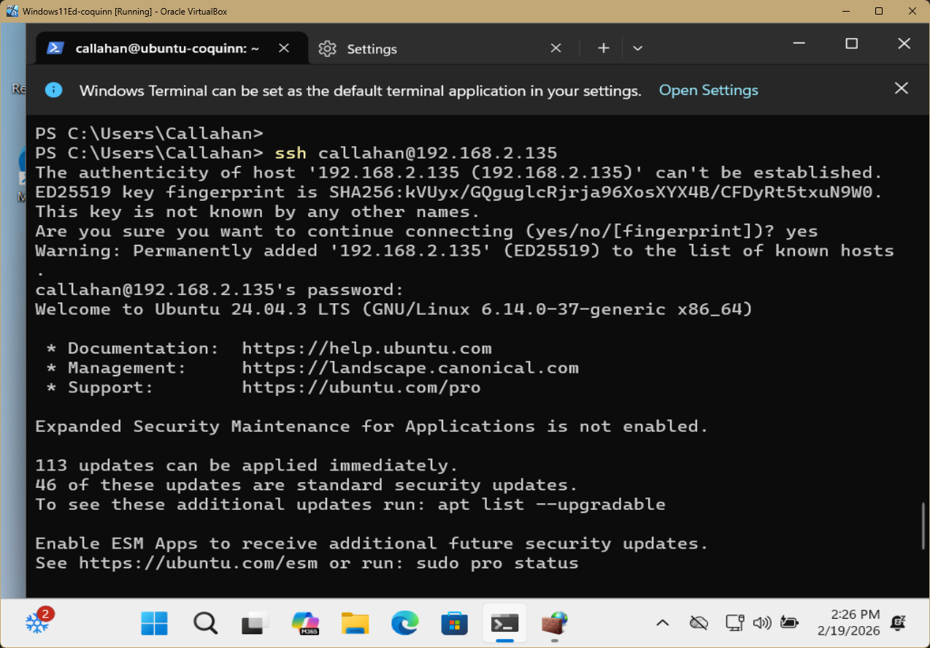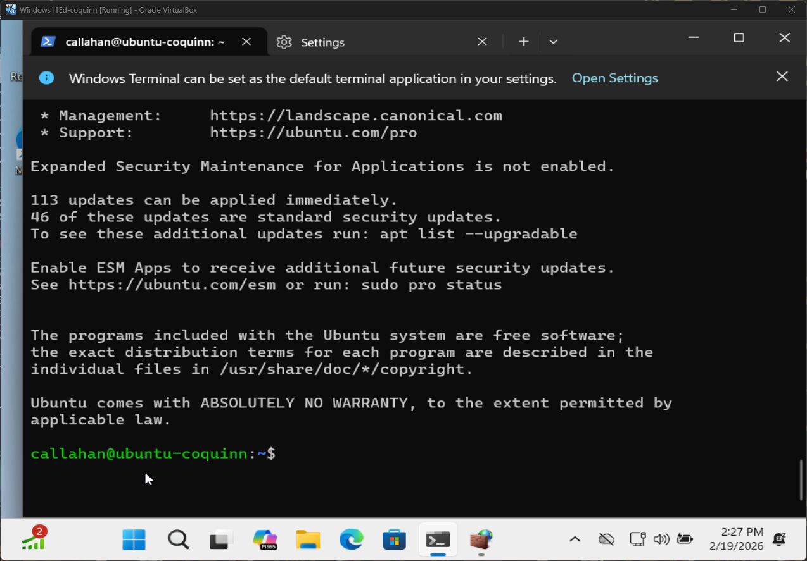

Questions
- Why should only required services be allowed between network segments?
  - The less services that are running/enabled/open, the smaller the attack surface is between segments.
- How does this reduce risk during an incident?
  - It is an effective mitigation tactic because it closes more doors an attacker can use to jump from one segment to another. It is super important to take note of open ports and running services, as every opening creates a potential for later movement.

Simulating a Network Quarantine

Block all traffic from the windows system
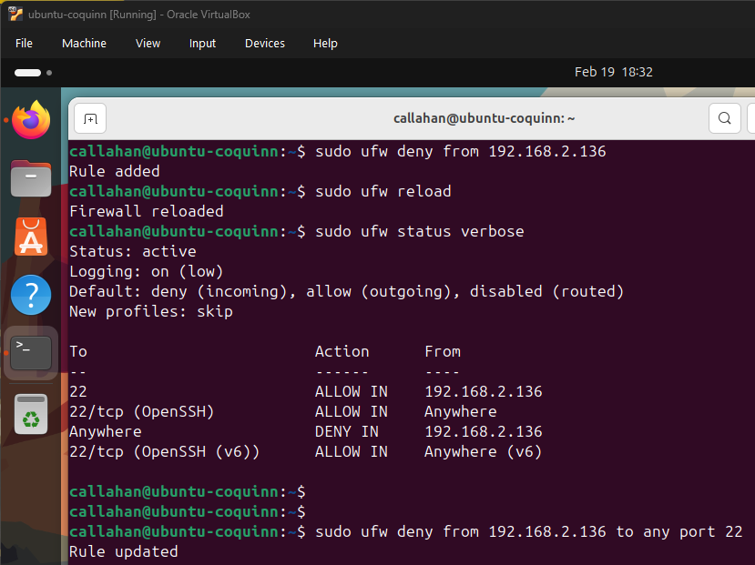

Trying to connect from the windows VM again
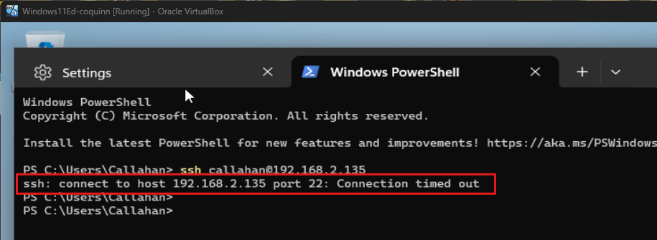

Questions
- How does this simulate a quarantine VLAN?
  - It simulates a VLAN quarantine by blocking all traffic from an exposed device/segment.
- Why should infected systems remain powered on during an incident?
  - Infected devices should remain powered on because depending on the attack, powering off may cause the virus to cause more harm (system corruption, data loss) or trigger the virus to spread laterally. Also, because of these effects, it may significantly hinder the investigation process.
- How does containment reduce ransomware spread?
  - It can stop ransomware from spreading to other network segments by blocking all traffic. This can potentially save more critical systems (ex. servers) or more critical data from being compromised.
- Why is segmentation critical for incident response?
  - Segmenting is critical to both reduce further damage and spread, as well as preserving important evidence for investigating the compromise.

